Troubleshoot connecting to SQL in Data Connector
BoostSolutions Data Connector provides a function to connect to an SQL server and sync data.
The goal of this guide is to help you troubleshoot general issues regarding not being able to connect to an SQL Server Database Engine. If in the event that your issue is not resolved or is not covered by this guide, please contact our support team for assistance.

Test a Local Connection
Before troubleshooting a connection problem from another computer, first test your ability to connect from a client application on the computer that is running SQL Server.
- Logon to the computer where SQL Server is installed, using a login that has permission to access SQL Server.
- On the Start menu, point to All Programs, point to Microsoft SQL Server 2008 R2, and then click SQL Server Management Studio.
- In the Connect to Server dialog box, in the Server type box, select Database Engine. In the Authentication box, select Windows Authentication. In the Server name box, type one of the following:
Connecting to: | Type: | Example:
Default instance | The computer name | Sql-2008r2
Named Instance | The computer name\instance name | Sql-2008r2\Testing
- If you can connect using shared memory, test connecting using TCP. You can force a TCP connection by specifying tcp: before the name. For example:
Connecting to: | Type: | Example:
Default instance | tcp: The computer name | tcp: Sql-2008r2
Named Instance | tcp: The computer name/instance name | tcp: Sql-2008r2\Testing
- If you want to connect SQL server with an account other than an administrator account, once you can connect as an administrator, try the connection again using the Windows Authentication login or the SQL Server Authentication login that the client application will be using.

Test Connectivity to SQL Server
Following these steps to make test if your SharePoint server can establish the connection to SQL Server.
- On the Start menu, click Run. In the Run window type cmd, and then click OK.
- In the command prompt window, type ping and then the IP Address of the computer that is running SQL Server.
- If your network is properly configured you will receive a response such as Reply from <IP address>. If you receive an error such as "Destination host unreachable." or "Request timed out." then TCP/IP is not correctly configured. Please contact your administrator to fix this issue.
- Next, test the connection using computer name. On the SharePoint server, in the command prompt window, type ping and then the computer name of the computer that is running SQL Server.
- If your network is properly configured you will receive a response such as Reply from <IP address>. If failure, please contact your administrator to fix this issue.

Enable Protocols
Connect to SQL Server from another computer, you need to enable the protocols. Otherwise, the connection will fail.
- On the Start menu, point to All Programs, point to Microsoft SQL Server 2008 R2, point to Configuration Tools, and then click SQL Server Configuration Manager.
- Using Configuration Manager, in the left pane expand SQL Server Network Configuration (or SQL Server Network Configuration (32bit)), and then select the instance of SQL Server that you want to connect to. The right-pane lists the connection protocols available. To connect to SQL Server from another computer you will normally use TCP/IP. If TCP/IP is not enabled, right-click TCP/IP, and then click Enable.
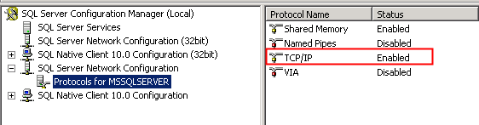
- Then restart the Database Engine. In the left pane select SQL Server Services. In the right-pane, right-click the instance of the Database Engine, and then click Restart.

Connect To an Correct Port
Get the TCP port number used by SQL Server. In most cases you are connecting to the Database Engine from another computer using the TCP protocol.
- Using SQL Server Management Studio on the computer running SQL Server, connect to the instance of SQL Server. In Object Explorer, expand Management, expand SQL Server Logs, and then double-click the current log.
- In the Log Viewer, click the Filter button on the toolbar. In the Message contains text box, type server is listening on, click Apply filter, and then click OK.
- A message similar to Server is listening on [ 'any' <ipv4> 1433] should be listed. This message indicates that this instance of SQL Server is listening on all the computers IP Addresses (for IP version 4) and is listening to TCP port 1433. (TCP port 1433 is usually the port used by the Database Engine. Only one instance of SQL Server can use a port, so if there is more than one instance of SQL Server installed, some instances must use other port numbers.)
- Type the server name and port in Database Server textbox like this: sql-2008r2,1699 (<server name>,<port number>)
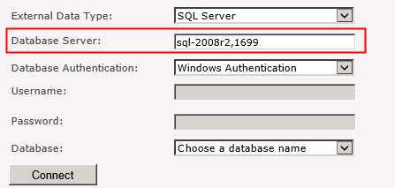

Open a Port in Firewall
To connect using TCP/IP from another computer, on the SQL Server computer you must configure the firewall to allow connections to the TCP port used by the Database Engine.
If you are connecting to a named instance or a port other than TCP port 1433, you must also open the UDP port 1434 for the SQL Server Browser service.
- On the Start menu, click Run, type WF.msc, and then click OK.
- In the Windows Firewall with Advanced Security, in the left pane, right-click Inbound Rules, and then click New Rule in the action pane.
- In the Rule Type dialog box, select Port, and then click Next.
- In the Protocol and Ports dialog box, select TCP. Select Specific local ports, and then type the port number of the instance of the Database Engine, such as 1433 for the default instance. Click Next.
- In the Action dialog box, select Allow the connection, and then click Next.
- In the Profile dialog box, select any profiles that describe the computer connection environment when you want to connect to the Database Engine, and then click Next.
- In the Name dialog box, type a name and description for this rule, and then click Finish.

Authentication Method
In Data Connector, there are two types of authentication to connect to an SQL server database, Windows Authentication and SQL Server Authenticaiton.
Windows Authentication
If you select this authentication type, Data Connector will use the application pool account to access the database server.
To connect to an SQL Server using Windows authentication, you must identify the Windows identity under which your web application is running. You must also be sure that the identity has been granted access to the SQL Server database.
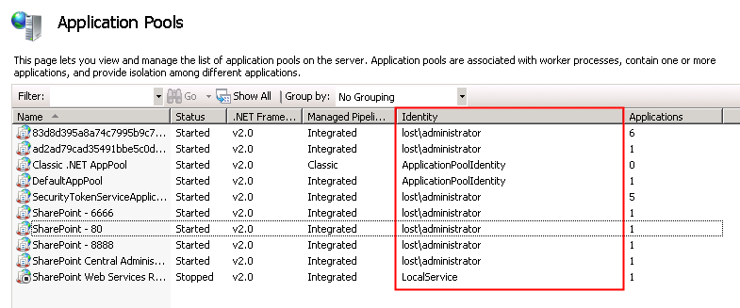
SQL Server Authentication
SQL Server authentication requires a valid SQL Server login name and password combination to validate the user access against the database.
To use SQL Server Authentication, the Database Engine must use mixed mode authentication (SQL Server and Windows Authentication mode is enabled).
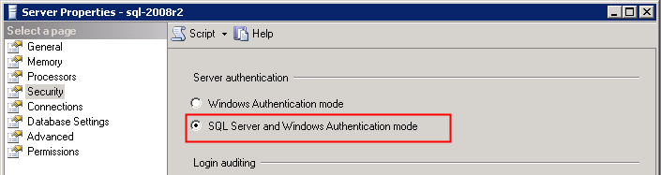

References:
http://social.technet.microsoft.com/wiki/contents/articles/2102.how-to-troubleshoot-connecting-to-the-sql-server-database-engine.aspx

