- Install Lookup Plug in SharePoint.
- Copy SharePointBoost.LookupPlug15.1.wsp to any directory such as D drive in your SharePoint server.
- Run SharePoint 2013 Management Shell by Farm Administrator by clicking Start-> All Programs->Microsoft SharePoint 2013 Products->SharePoint 2013 Management Shell
- Run addsolution command as following to add solution to SharePoint:
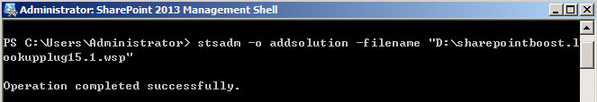
- Then run the deploysolution command to deploy it, Please notice the url “http://server2013” should be replace by your own web application url:
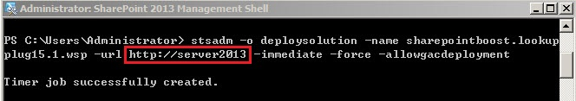
- Please go to SharePoint Central Administration -> Application Management-> select the web application -> Manage Features in the Ribbon, make sure the feature is activated:
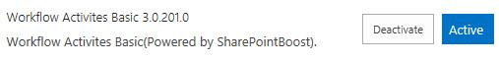
- Open SharePoint Designer 2013, a new activity “Copy Lookup Field Value” shows in action list:
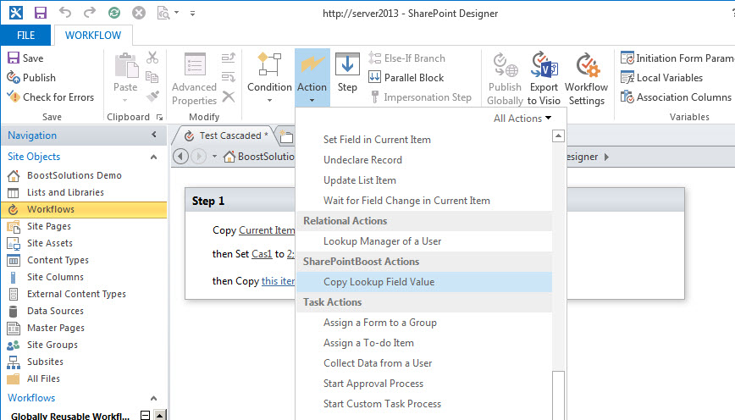
Note: please deactivate feature first before retract & remove the solution.
- Get value from Cascaded Lookup field
Please first copy Cascaded field value to a variable, then set it the other fields.
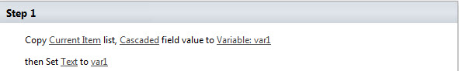
- Assign value to Cascaded Lookup field
To assign value to Cascaded Lookup field, this activity is not required, but please make sure the format follows “id;#value” .

